Osan Scheduler How-To

1. Summary

This web-based application was developed to ease the burden on administrators in providing a comprehensive team/site/employee schedule and produce the required reports required by the various customers. A team is the overall group that is usually divided into sites with a leadership element. A site also has a small leadership team and broken down into work centers where most of the employees are assigned.

This tool will allow each user to see various aspects of the application depending on their role within the team and site. The roles include:

1. Employee – Everyone with a access account on this application is initially an employee. This is the lowest common denominator and is given the least privilege to updating necessary data.
2. Site Scheduler - The site leader will select this individual who will be responsible setting all site employee’s schedules and variations (these terms explained later). This person will also prepare the site’s reports and email it out to the various recipients. They will also be able to edit employee data to include their profiles, change passwords, unlock accounts, edit company information, assign primary labor codes, edit approved leave, edit leave starting balances and submit leave requests for the employee.
3. Site Company Lead – Since the team is probably composed of a main company plus a portion of the team composed of personnel from other companies. Work completed and leaves taken require are included in the timecard ingest/manual entry and this is the responsibility of the site’s company leads. They ensure their timecard system data is ingested or manually entered, so this is the area the site company lead has access to.
4. Site Leader – Site leadership isn’t just the site lead, but also anyone assigned a leadership position where assignment actions are decided, and leaves approved. A Site Leader has all the permissions of the Site Scheduler plus leave approval.
5. Team Leader – Team leadership are the overall decision makers deciding on team composition and contract maintenance. Because of this, they are granted the capability to add/edit/delete sites and their employees.
6. Application Admin – This is the highest role in the application and granted only to the application administrator(s). They have full permissions to add/edit/delete teams plus purge old data by date.
7. Terms:
   1. Assignment – This refers to the normal work schedule over a period of time. All employees have at least one assignment which also annotates when the employee started working for the team/site and when their last day of work was. An assignment can have multiple schedules. If multiple schedules are to be used and rotated through, the assignment can designate a date to rotate upon and the number of days between changes. The selection of the assignment workday by date is checking for a rotation period and date, finding which schedule to use, then determine with days within that schedule to provide.
   2. Schedule – The schedule is defined as a group of days (must be a multiple of 7) to be used to define the workdays for the assignment. All schedule days start on a Sunday (first day of the week) and include a multiple of 7 days.
   3. Workday – A workday contains the work code for a particular day numbered within the schedule, the work center assigned for that work and the number of hours expected to be worked. A blank workday includes a blank code, a blank work center and zero hours.
   4. Variation – A variation is defined as a temporary alteration in the employee’s normal work schedule. As an example: The employee works Tuesday through Saturday, 8 hours per day, working day shift in the GEOINT work center, but you need them to work Mid Shift for 4 weeks. You create a variation with the scheduled start and end dates for the variation, plus assign the variation’s schedule to the proper mid work code, work center and number of hours. If the site is using a mid-rotation, you should set the IsMids flag of the variation to true. A variation only has one schedule and can be set to whatever multiple of 7-day period to use.
   5. Leave – A leave is any non-workday. It could be vacation time, a holiday, military or jury duty, or a few other options. These are started by completing a leave request and the individual’s supervisor approving the leave. All leaves include a leave code to show what type of leave it is and the number of hours to be used. The system automatically adds a leave status (Actual, Approved, or Requested) to show where the leave is in the process.
      1. Actual Status – This is normally determined by ingestion of the timecard data or from the company lead’s timecard manual input.
      2. Approved Status – This signifies that the supervisor has approved the leave request and will remain in this status until the timecard data modifies the status that the leave was actual taken.
      3. Requested Status – This signifies that the employee has requested the leave, but the supervisor hasn’t approved it yet.
8. Procedures:
   1. View Layout

Note: The view below is after log in

* + 1. Top/Toolbar

At the top of the window/browser is the toolbar. IT provides the place to make the menu visible/hidden, shows the Team Name and Site Name the logged individual is assigned to. The other end of the toolbar shows the logged individual’s first name, the Icon to be used to log out, plus a button to access the on-line help.

* + 1. Menu

The menu provides the access to the various view and editing options the logged in user’s permissions allow.

* + 1. Main View Area

The menu choice’s display will show in this area.

* + 1. Bottom/Status Bar

The blue area at the bottom will display error messages and/or other status messages from the server.

* 1. Logging In/Out

* + 1. Logging In

Only authorized individuals can access the data associated with this web application, so you must log into the system for access.

1. Type in the user’s registered email address into the space provided as show above.
2. The next text entry area is for the account’s password. It doesn’t display, but display’s only a string of asterisks for each character typed in.
3. Click the “Login” button below the password entry area to send the login information to the server to log in.

If the information sent is accurate, the employee calendar portion of the application will be shown, otherwise you may see a login status message to the left of the log in button.

* + 1. Logging Out

Once you are logged into the application, you will stay logged in, for a period of time, even if you refresh your browser. To remove this capability, log out of the application by clicking the lock in the toolbar. This will log you out and return the browser display to the log in screen.

* 1. Employee
     1. Schedule

This schedule is provided in calendar format showing all the employee’s work assignments and approved leave during the selected month. To change the displayed month:

1. Click the “<<” button at the top-left to go back one year.
2. Click the “<” button at the top-left to go back one month.
3. Click the “>” button at the top-right to go forward one month.
4. Click the “>>” button at the top-right to go forward one year.

The display is view only, so other than selecting the month to view, no other actions are possible. Grayed out areas are for previous and next month’s days. Each work or leave day displays with the assigned color scheme for the large code in the middle of each day. The box in the upper-right of each day block reflects the day of the month, today is colored in a red tint, while weekends are cyan. The large 1–2-character code in the middle of the day block shows the work or leave code. The word(s) at the bottom of the day block are the only for workdays and show the work center within the site the individual is to work at. The system determines which code to display by finding the individual’s current work assignment for the day, then checks for any workday variations annotated, and lastly looks for approved leave. The priority of display is the reverse or leave-variation-assignment data is displayed.

* + 1. PTO/Holiday Listing

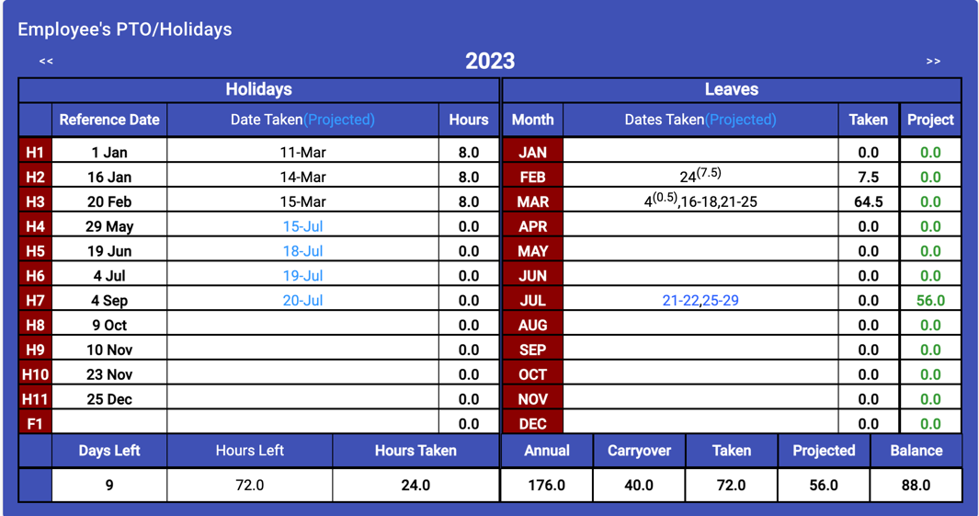

(Employee Report for Company with PTO and Holidays)

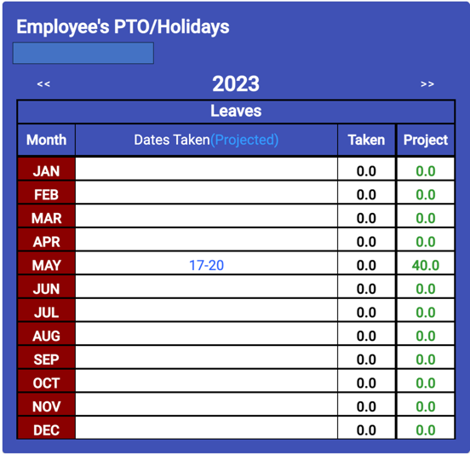

(Employee Report for Company with PTO Only)

The Employee’s PTO/Holiday report shows all the actual and/or approved holidays and leaves to allow the employee to plan and provide a projection of time off to their respective supervisors. Since some companies provide only vacation time to their employees, the display is based on the company defining their paid holidays, if none are assigned, only the leave portion of the display shown.

* + - 1. Holiday Display – This display shows the holidays designated by a company for the employee.
         1. They are defined in the Team’s Data section, covered later, and are coded and sortable.
         2. The display provides the holiday’s code, the date for this holiday during the displayed year, the date the holiday was taken by the employee or projected, and the last column shows the number of hours taken/used.
         3. Company policy will dictate the standard number of hours for each holiday and whether or not partially holidays can be taken and combined. Partial holidays are shown as a date with the number of hours taken.
         4. Holidays taken are displayed in black lettering and projected holidays are shown in a blue shade.
         5. Holidays are filled into the display in date order with partial holidays combined to show a complete holiday taken.
      2. Leaves Display – This display shows all the other types of time off an employee uses during the year.
         1. The leaves are grouped by month.
         2. Paid-time-off (PTO) or vacation time is displayed in the same way as holidays with black for actual dates and blue shade for projected. All other leaves use a reverse coloring of the calendar, so if the leave is shown as black lettering on a yellow background in the calendar, it will be displayed as yellow lettering on a black background.
         3. The “Taken” and “Projected” columns on the right are to show the amount of taken and projected vacation time the employee has taken or has projected to the end of the year. The application is written to assume that other types of leave doesn’t count against the employee’s vacation total.
      3. Holiday/Leave Summary - The summary at the bottom of the display provides a ready reference for the number of holidays left and the amount of PTO/Vacation time the employee has remaining/unscheduled. This display will only be shown leave balances are provided to the application by the scheduler/site leadership, so that a balance can be determined.
         1. The display is again broken down to Holidays and PTO/Vacation sections (left and right). The holiday section is based on actual holiday time taken, so the totals show the number of holidays not taken yet, the number of hours available to be taken to the end of the year, and the number of hours taken so far. The PTO/Vacation section shows the number of hours carried over from the previous year, the number of hours projected for the calendar year, the number of hours taken and the number of hours projected. The balance is simply a calculation of the hours available minus the hours taken/projected or (annual PTO hours + carried forward) – (taken + projected)
    1. Profile

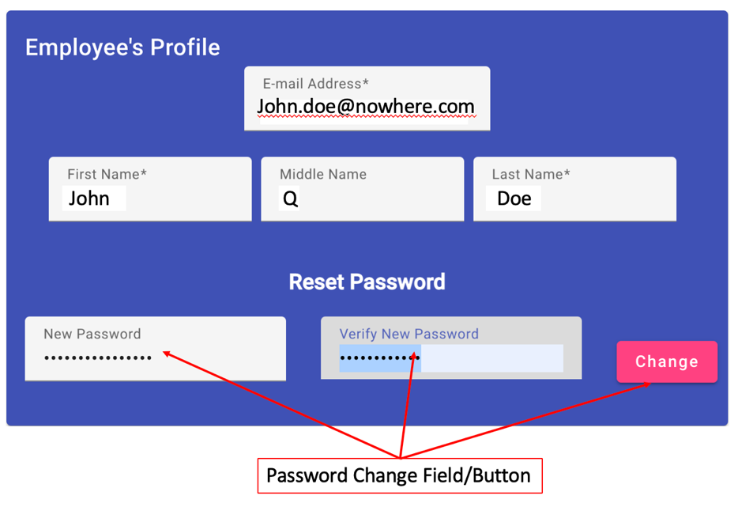

* + - 1. The employee can modify their own profile, to include their name and E-mail address, so the above display is provided. The E-mail address will be the one used for logging into the application and the name listed will appear on all the reports. To change any of these fields:

1. Place the cursor in any of these fields shown above and click the left mouse button.
2. Use a keyboard to make any changes.
3. Hit the <Tab> key or click the mouse in any of the other boxes to save the change.
   * + 1. The employee can change their log in password on this display also. They will need to:
4. Place the cursor in the “New Password” field and click the left mouse button.
5. Type in the new password in the field. You may have to remove the asterisks, as these are characters you may not know.
6. Hit the <Tab> key or click in the “Verify New Password” field.
7. Type in the new password again.
8. Click the “Change” button on the right.

The new password has several minimum requirements:

1. 10 characters minimum.
2. 2 of each type of character (upper-case, lower-case, numeric, other characters)
   * 1. Leave Requests – Requesting leave (any type) will start here with the Leave Request Editor. (Note: the example used below are for a vacation over a two week period but will consist of several holidays in conjunction with the normal vacation days.)

* + - 1. The Leave Request Editor opens as a blank slate, with the possible exception of the “Current Leave Requests” list have some leaves shown.
      2. Adding A New Leave Request:

1. Click on the “Request Dates” field-Calendar Icon and a calendar will display to allow you to select the entire period you will be on leave. This includes regular days off, so that if your schedule is changed in the future, the leave can be automatically re-calculated.
2. Click on the first day of the leave, then the last day of the leave.
3. Now, move the cursor to the “Primary Leave Code” selector and choose the type of leave that will be used the most during the period. You will be able to set individual days separately later.
4. Now click the “+” button to the right of the primary code selector. This will create a new leave request with your normal work days scheduled with the primary code.

1. Now this leave request is NOT approved and is only in the REQUESTED state. If you want to change some of the days to Holidays, you can edit individual days by going to that day and changing the type of leave to use/project for that day and the number of hours. When you change it’s leave type the color scheme will probably change.

* + - 1. Editing a Leave Request – The employee can make changes to the leave request until it is taken, but each time a change is made, if the leave request’s inclusive dates are changed, the leave request returns to a REQUESTED status, even if it had previously been approved.

1. The first step is to choose the leave request from the list of “Current Leave Requests”. Click on the leave request to edit. This will change the display to show the leave request’s current state.

1. Below the date selector is the request’s current status, it tells you the request’s creation date, status, and if approved, by whom and when.
2. You can edit any of the data for the request noting the caveat listed in step 1 of these steps.
   * + 1. Removing the Leave Request from the Display – Once you choose a leave request and it’s displayed, the system thinks that you are editing the chosen leave request. So to clear off the display and get back in the “Add” mode, click the Clear button ( A picture containing electric blue, blue, symbol, graphics

          Description automatically generated ) to the right of the Primary Leave Code selector.
       2. Deleting a Leave Request – This is a three-step process where the first step is to select the leave request to delete, then click the Delete button ( A pink and blue recycle bin

          Description automatically generated with low confidence ) and finally to validate or confirm the deletion.
   1. Site Schedules. These items are read-only and only allows you to change the view period.

* + 1. Schedule – (All site personnel can view) The site schedule can be separated into two parts: 1). Schedule portion and 2) Legend.
       1. The schedule portion provides the complete schedule for the site by month, work center, then by shift within the work center. The example schedule above shows the month of June 2023, with work centers for Leads, GEOINT and HB/LB. These work centers and their respective shifts are defined by the site using the site editor (discussed later). The employees at the site are assigned to one of the work centers and through their respective work assignments to shifts or positions. As you can see some work assignment and most leaves have color coding these are defined in the legend.
       2. At the top of the schedule, four buttons are shown to allow the viewer to move between the months/years.

“<<” button will move the display backward one year.

“<” button will move the display backwards one month.

“>” button will move the display forward one month.

“>>” button will move the display forward one year.

* + - 1. The legend portion shows the various color code schemes and their meanings for the schedule. These don’t include anything that is a normal background, which are used for most work assignments.

* + 1. Coverage – (Site supervisor view only). The site coverage display is a companion to the site schedule, showing the number of employees working on the shifts for those work centers with shifts. This helps the supervisor ensure enough people are scheduled for a particular shift. The minimum number of workers per shift is defined in the site editor (discussed later) as part of the shift definitions. If a shift on a particular day is below minimums, it is highlighted in pink.

* + 1. Mid Rotation Coverage – (All site personnel for sites with a Mid Shift Rotation). The Mid Rotation Coverage listing provides a ready list of who is working the mid-shift rotation and the start and end dates for their period. It is a simple list shown in start date order for the entire year. Mid-shift rotation is set using an assignment variation in the Employee Editor (discussed later) and defines that employee’s work period and days off. To see a different year’s assignments, use the “<<” and “>>” buttons to move the year backward or forward one year, respectively.
  1. Editing
     1. Employee Editor (Site Scheduler/Leadership only)
        1. The Employee Editor is the one-stop view for editing all things site employees. The display is broken down into the employee list with an “Add New Employee” button and the selected employee’s editor views. Many of these views are the same as the employee sees, only the site scheduler/leadership can select the employee to view, where the employee only sees their information. These include:

* + - * 1. New Employee – Adding a new employee is a 4-step process where you are provided four different forms to create the smallest amount of information to create the new employee.

Form 1) Basic Information to include email address, name and password.

Form 2) Company Information to include the company name, their company id, and job title, but you can add an alternate company id, rank or grade, cost center, and company division.

Form 3) The new employee will work on one primary labor code, so you should select one, unless the company doesn’t use labor codes, then they will be assigned using their work center and the current year.

Form 4). Initial Assignment information to include their assigned work center, the date they started work and their initial work schedule days.

After all the required data is filled in, an “Add” button will display at the bottom of the view. Click this button to create the new employee with the information provided.

* + - * 1. Selecting an Employee – There are a few things at the bottom of the employee list on the right of the screen that need explanation.

1. The “Show Active Only” checkbox allows the scheduler to decide whether to show employees in the database that have left and/or no longer assigned to the site.

1. The “Password Expired” and “Account Locked” buttons below the “Show Active Only” at the bottom of the list are a legend to explain when employees’ names are displayed with these color schemes.
   * + - 1. Personal Information. Most of this view is the same as the employee’s profile view but adds the ability to set their role(s). See sections 3.3.3.1 and 3.3.3.2 for changing an employee’s email address, name and password.

Password Expired: An expired password can only be changed by setting a new password, so use the “New Password” and “Verify New Password” and the “Change” button to change the employee’s password.

Locked account: When an employee’s account is locked, this means the employee has given the wrong password too many times. The employee’s name will display with their button like that above (pink) and when you click on them, you will see a “Unlock Account” button displayed. Click on this button to clear the lock and allow them to try again.

Setting Employee’s Permissions/Roles:

* + - * 1. Company Information
        2. Assigned Labor Codes
        3. Assignments
        4. Variations
        5. PTO/Holiday Lists
        6. Leaves
        7. Leave Balances
        8. Leave Requests
    1. Leave Approval
    2. Site Editor
    3. Timecard Ingest/Manual Timecard Entry
    4. Team Sites Editor
    5. Team Editor
    6. Teams Editor
    7. Data Purge
  1. Report Creation
     1. Report Creator
        1. Team Schedule
        2. PTO/Holiday Listing
        3. Charge Number Status
        4. Mid-Shift Rotation
        5. Certificate of Service (CofS)